Statistics Lecture 2.2: Creating Frequency Distribution and Histograms

Frequency Distribution: A list of values with their coresponding frequecies.

Class Width: Difference between “two lower class limits”.

Lower Class Limit: The smallest value belonging to a class.
Upper Class Limit: The largest value belonging to a class.
Class Midpoint: (Upper class limit - lower class Limit) Divided by two
Class Boundaries: Used to separate classes without gaps. Always get one more class boundary than classes (used for histogram only
Relative Frequency Distribution: percentage of the total frequency by class
CumulativeFrequency Distribution: Adds sequential classes together

Normal Data rises to a peak and then falls off.

STEPS:

1.Determine number of classes: (8) too few or too many cannot determine any trends.

2. Class width: 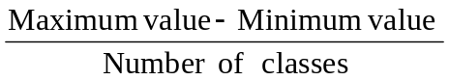
Class width must be a whole number ( round upward.)

44-18/8 = 3.25 = roundup(3.25)=4
- Start with smallest value 18
- Create classes with class width
* lower class limits first
- Class Midpoint:
- Class Boundaries:
- Relative Frequency Distributio

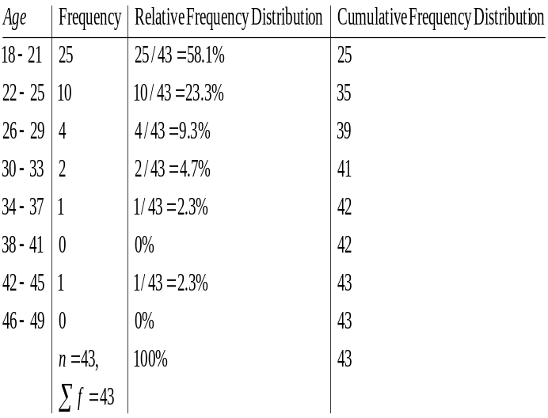

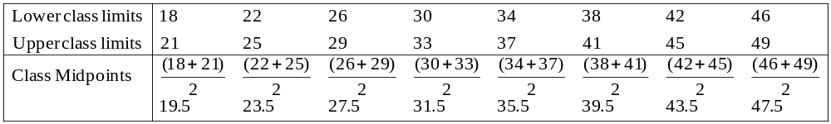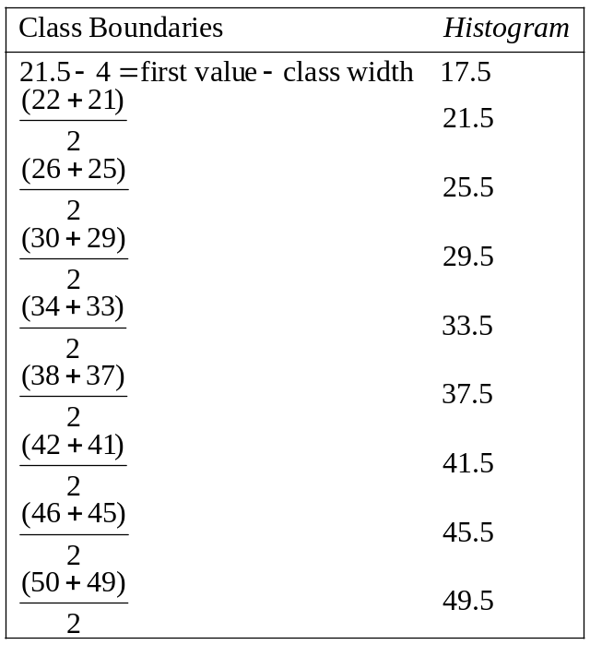

Histogram: Touching Bar Chart.

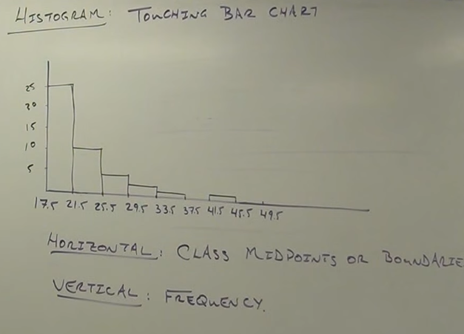

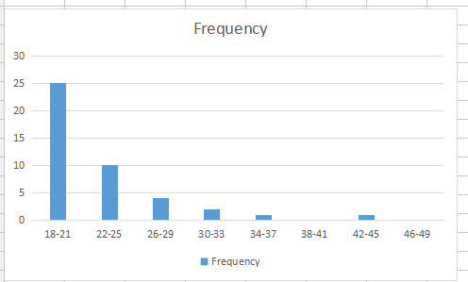

Midpoints
